# Top 4 most popular places in Lund (ranked in Tripadvisor by number of reviews by tourists) + Lund University Main Building

1. Lund Cathedral: 1,009 reviews
2. Botanical Gardens: 502 reviews
3. Kulturen in Lund: 324 reviews
4. Stadsparken: 141 reviews
5. Lund University Main Building: 55 reviews

# Findings by Language:

|  |  |  |  |  |  |
| --- | --- | --- | --- | --- | --- |
| Language | Average score | Number of reviews | Sentiment Analysis | Ave Author vote | Ave Author contribution |
| [Finnish] | 3.00 | 1 | 0.300 | 4 | 15 |
| [Indonesian] | 4.00 | 3 | 0.204 | 131 | 640 |
| [Japanese] | 4.12 | 33 | 0.257 | 54 | 282 |
| [Danish] | 4.24 | 93 | 0.376 | 42 | 119 |
| [French] | 4.29 | 42 | 0.406 | 80 | 196 |
| [Portuguese] | 4.31 | 26 | 0.363 | 21 | 68 |
| [Spanish] | 4.37 | 35 | 0.381 | 105 | 166 |
| [Turkish] | 4.40 | 5 | 0.398 | 38 | 72 |
| [Dutch] | 4.43 | 14 | 0.423 | 70 | 170 |
| [Swedish] | 4.47 | 641 | 0.362 | 18 | 77 |
| [English] | 4.48 | 955 | 0.333 | 54 | 125 |
| [Italian] | 4.49 | 47 | 0.384 | 85 | 280 |
| [Chinese, (Sim.)] | 4.52 | 23 | 0.370 | 42 | 97 |
| [German] | 4.58 | 50 | 0.396 | 49 | 148 |
| [Russian] | 4.60 | 30 | 0.358 | 64 | 170 |
| [Norwegian] | 4.70 | 10 | 0.436 | 19 | 99 |
| [Polish] | 4.78 | 9 | 0.317 | 35 | 126 |
| [Chinese, (Trad.)] | 4.82 | 17 | 0.356 | 43 | 98 |
| [Greek] | 5.00 | 1 | 0.500 | 15 | 14 |
| [Hungarian] | 5.00 | 1 | 0.418 | 4 | 7 |
| [Thai] | 5.00 | 1 | 0.396 | 3 | 12 |
| [Serbian] | 5.00 | 1 | 0.639 | 7 | 46 |

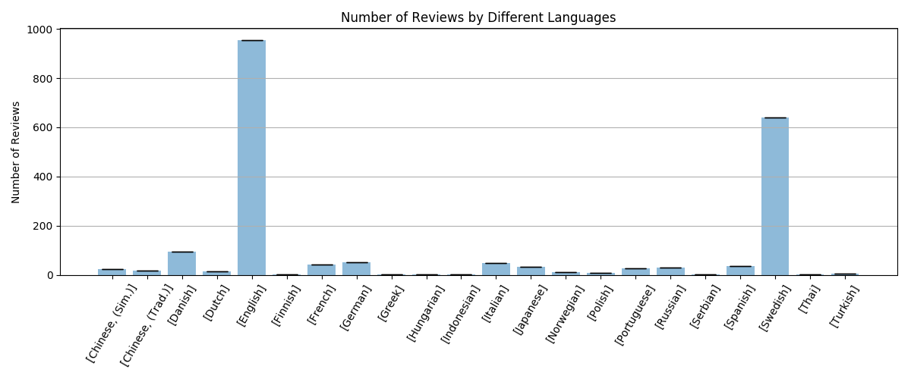

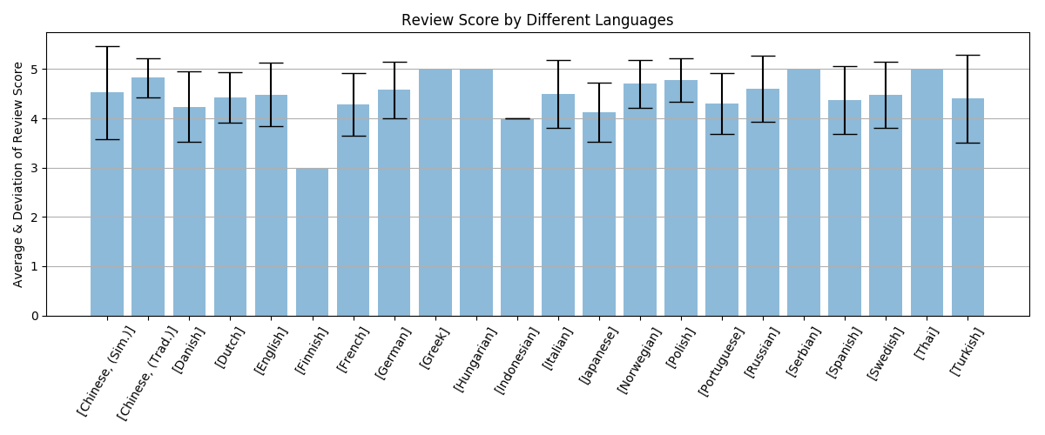

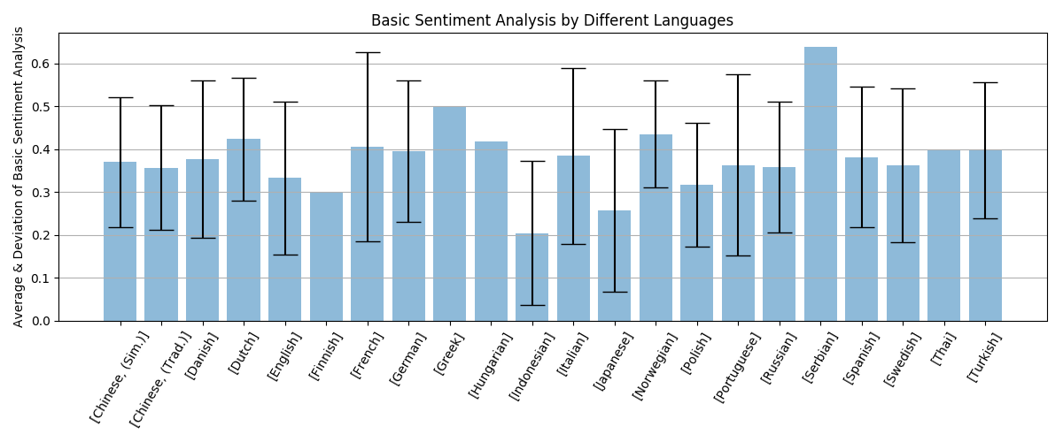

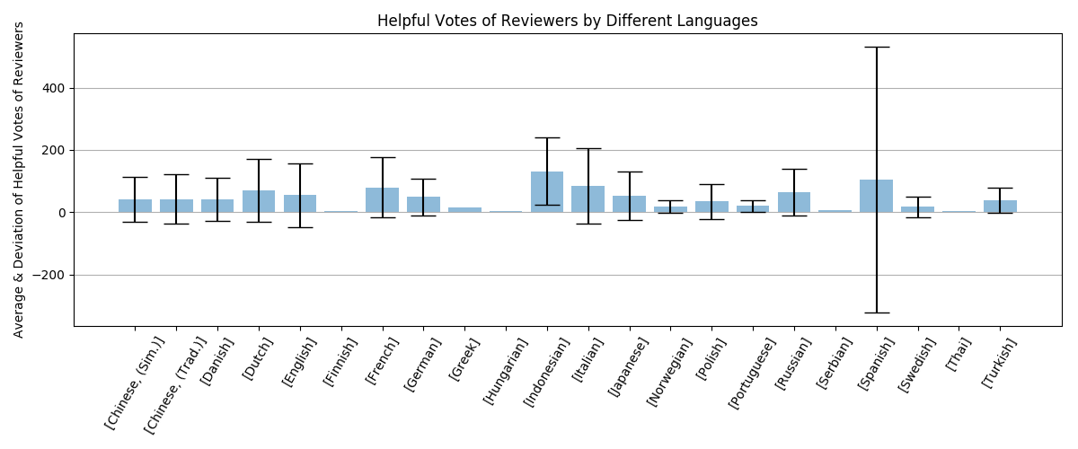

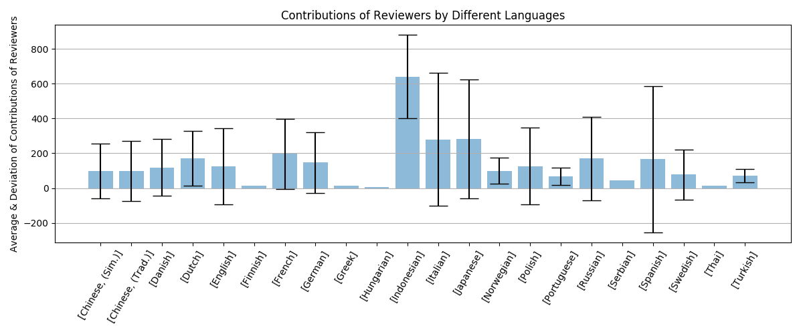

# Topic Modeling by Different Language:

## English:

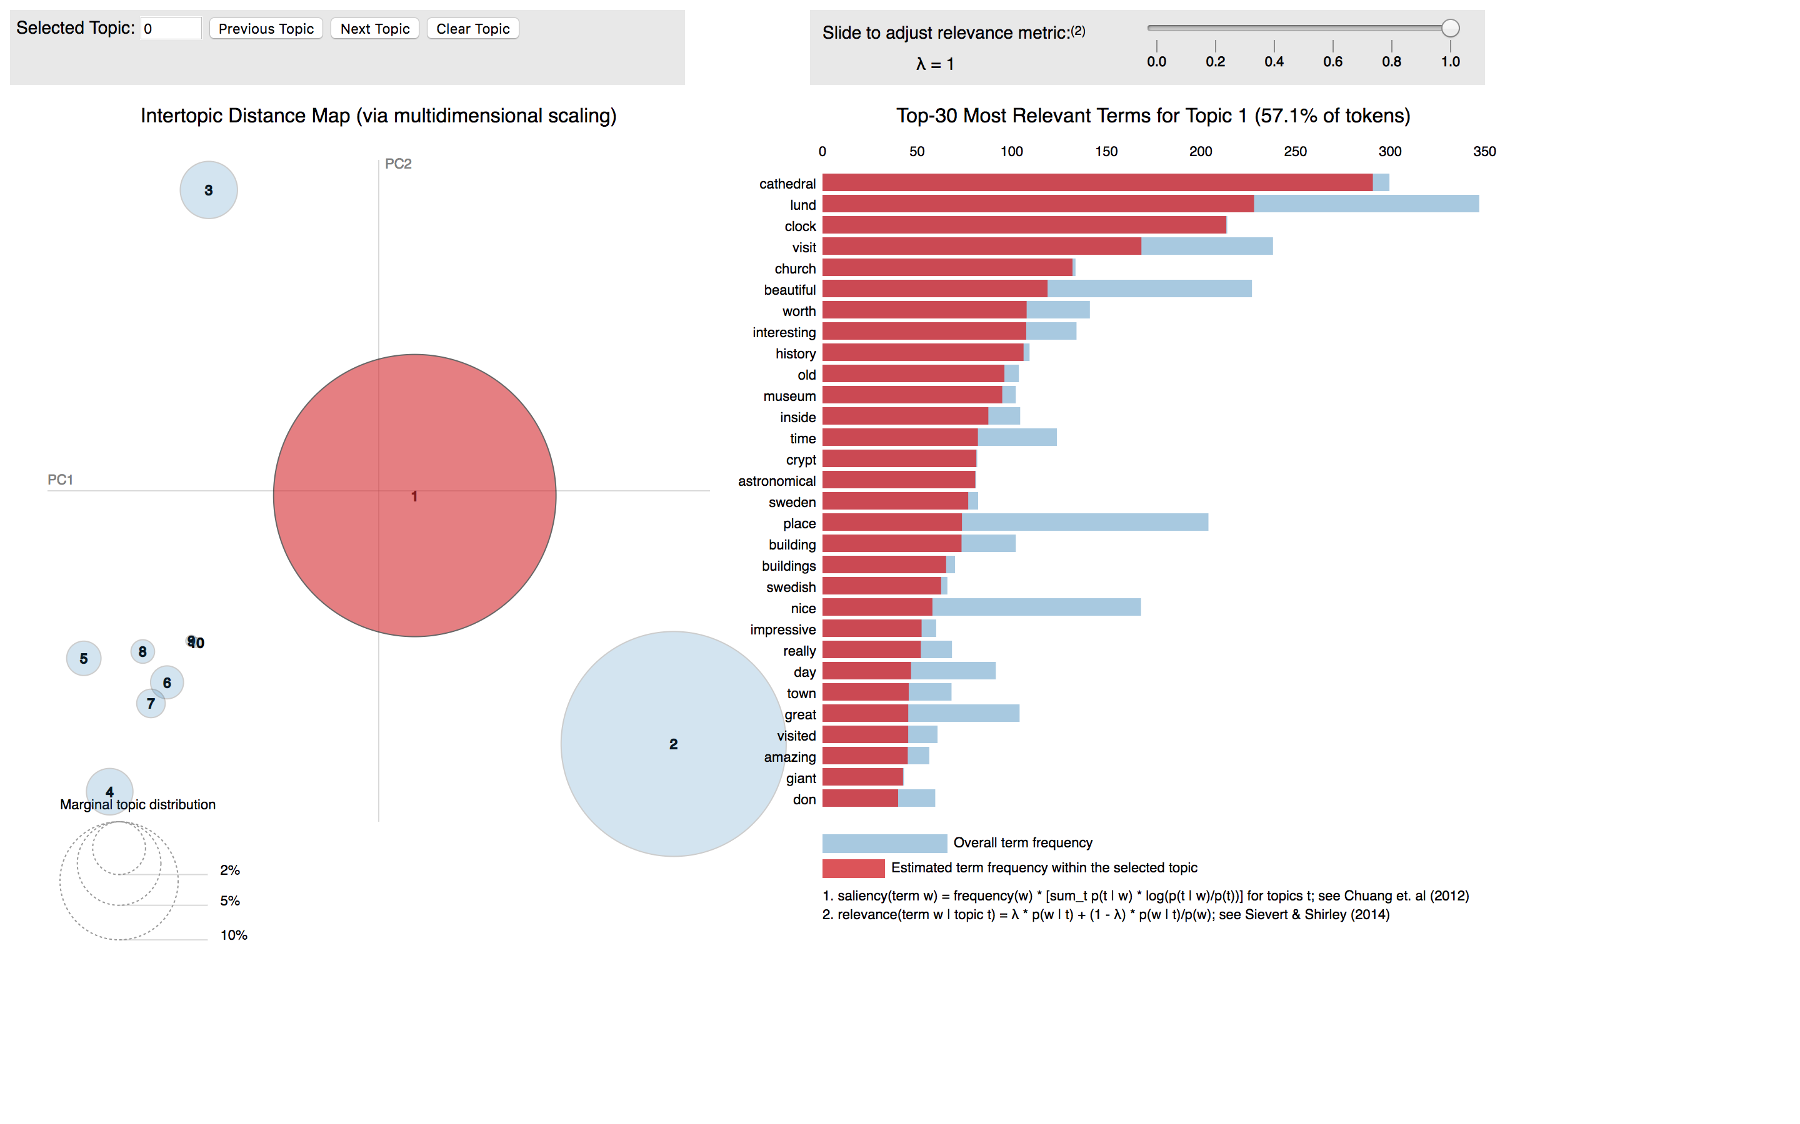

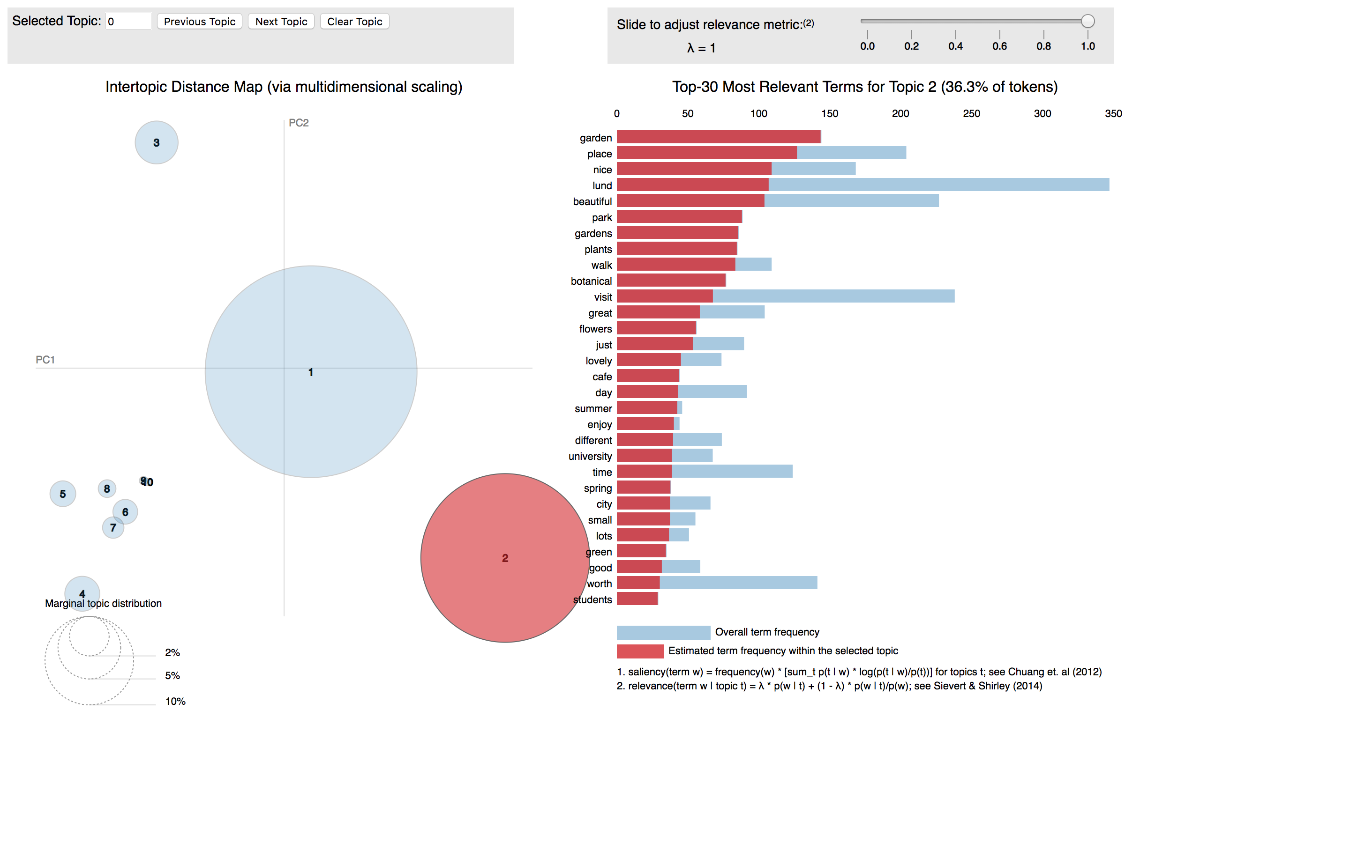

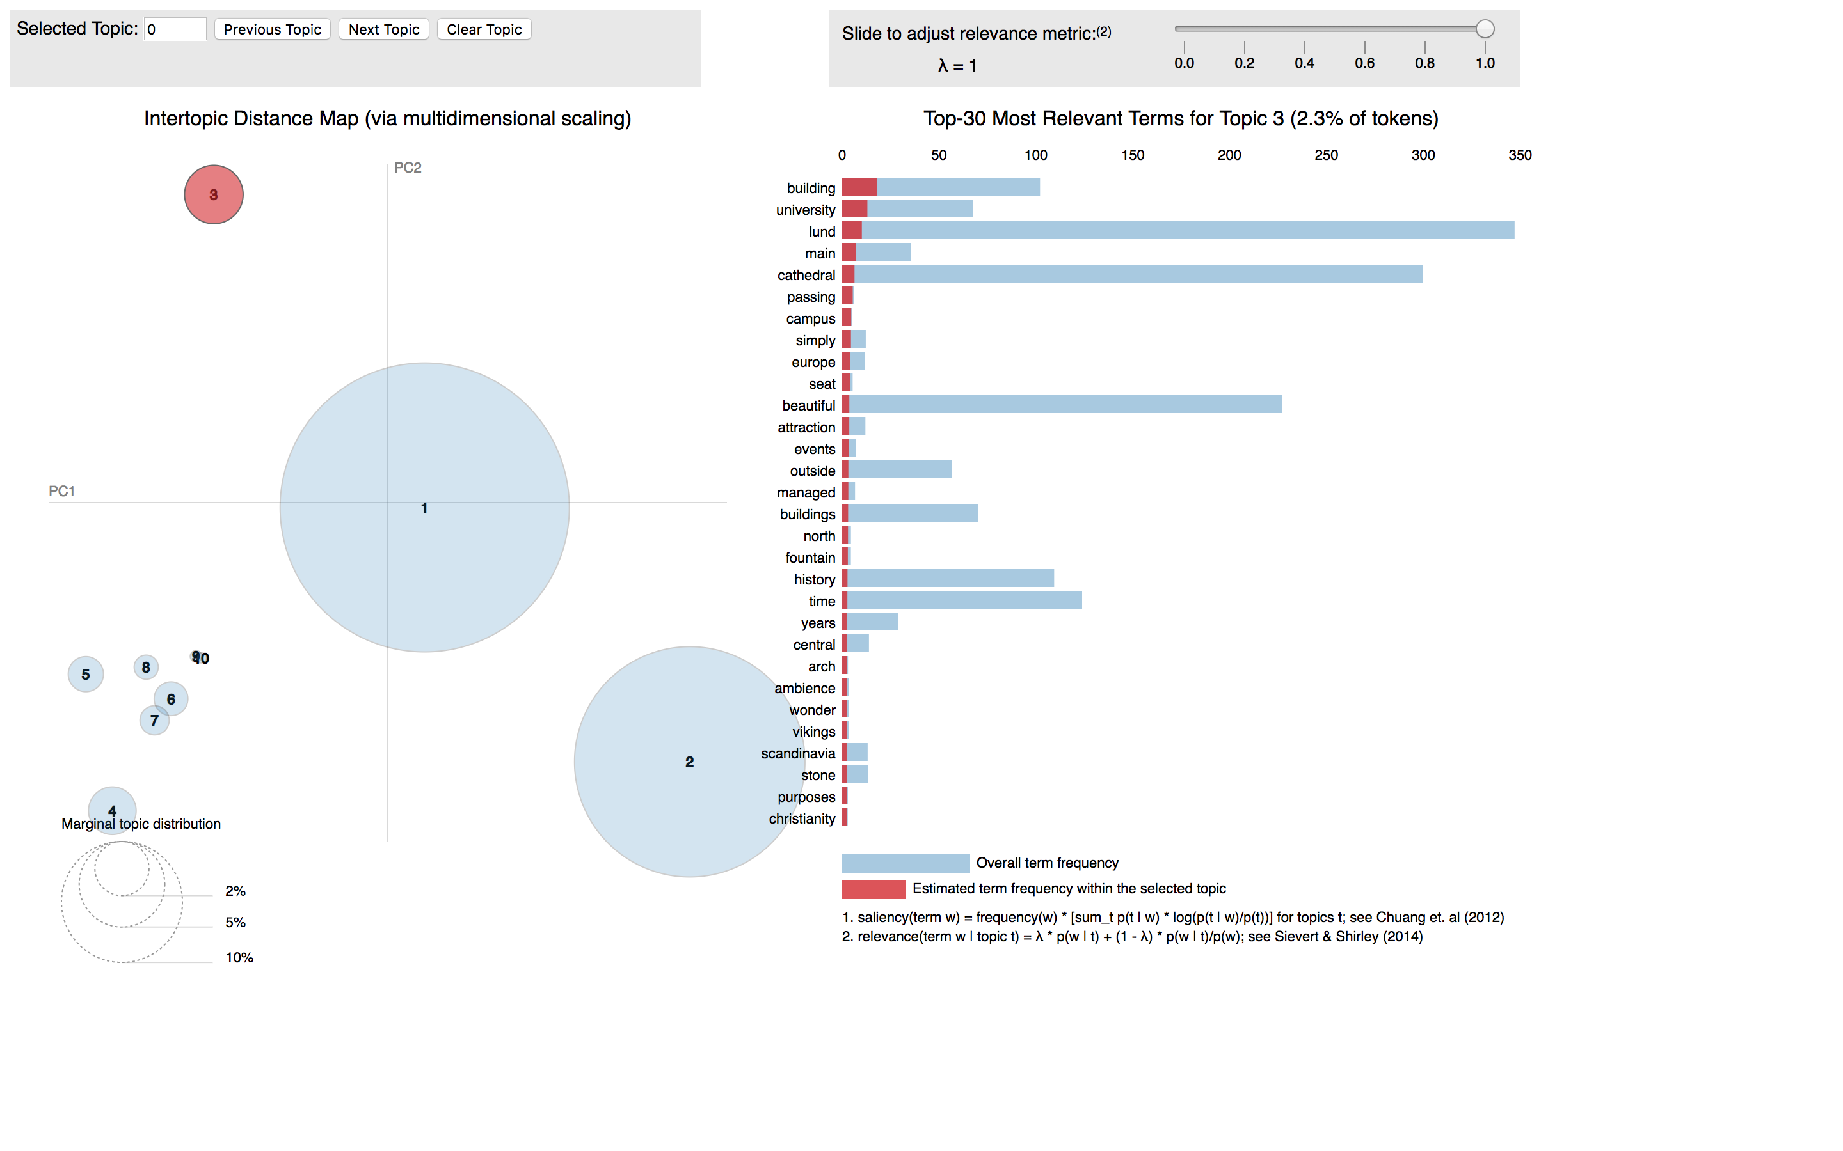

## Swedish:

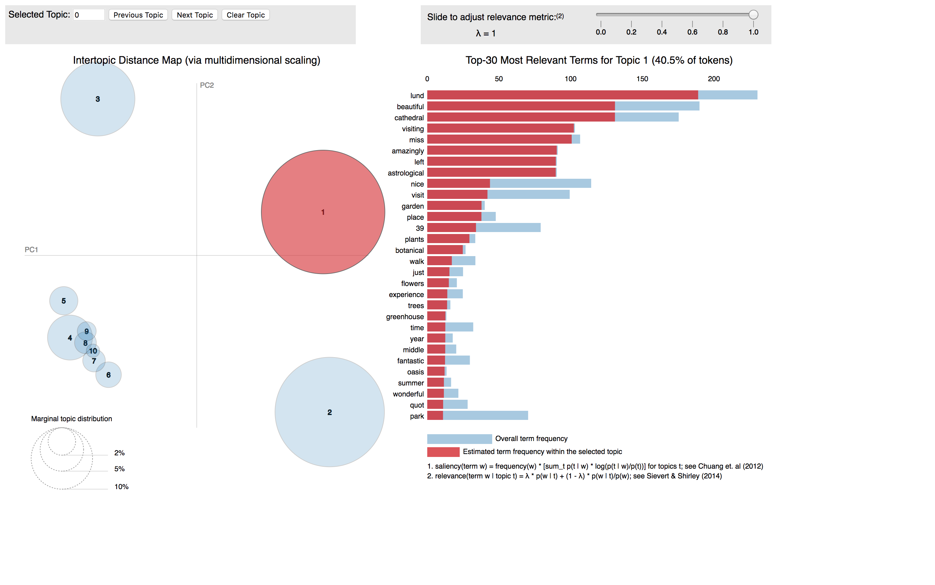

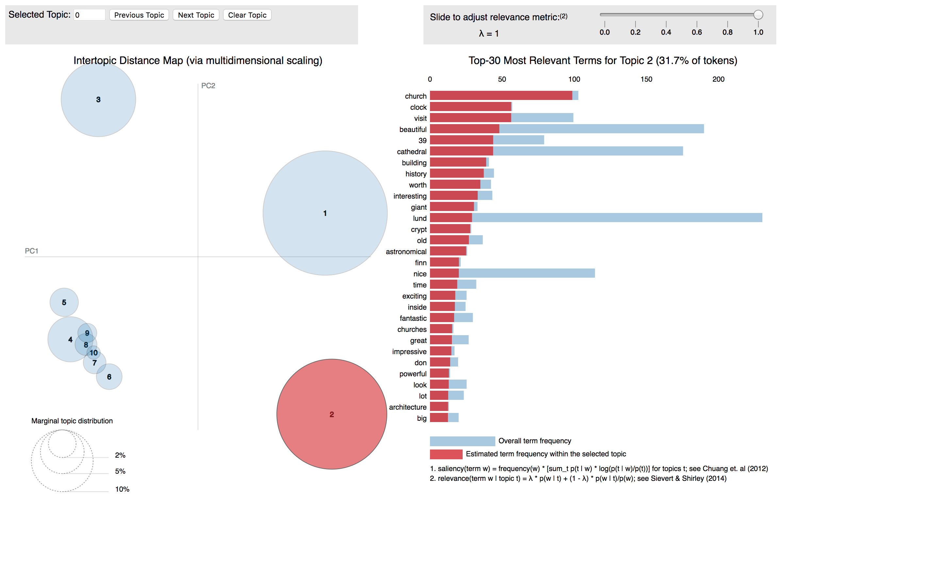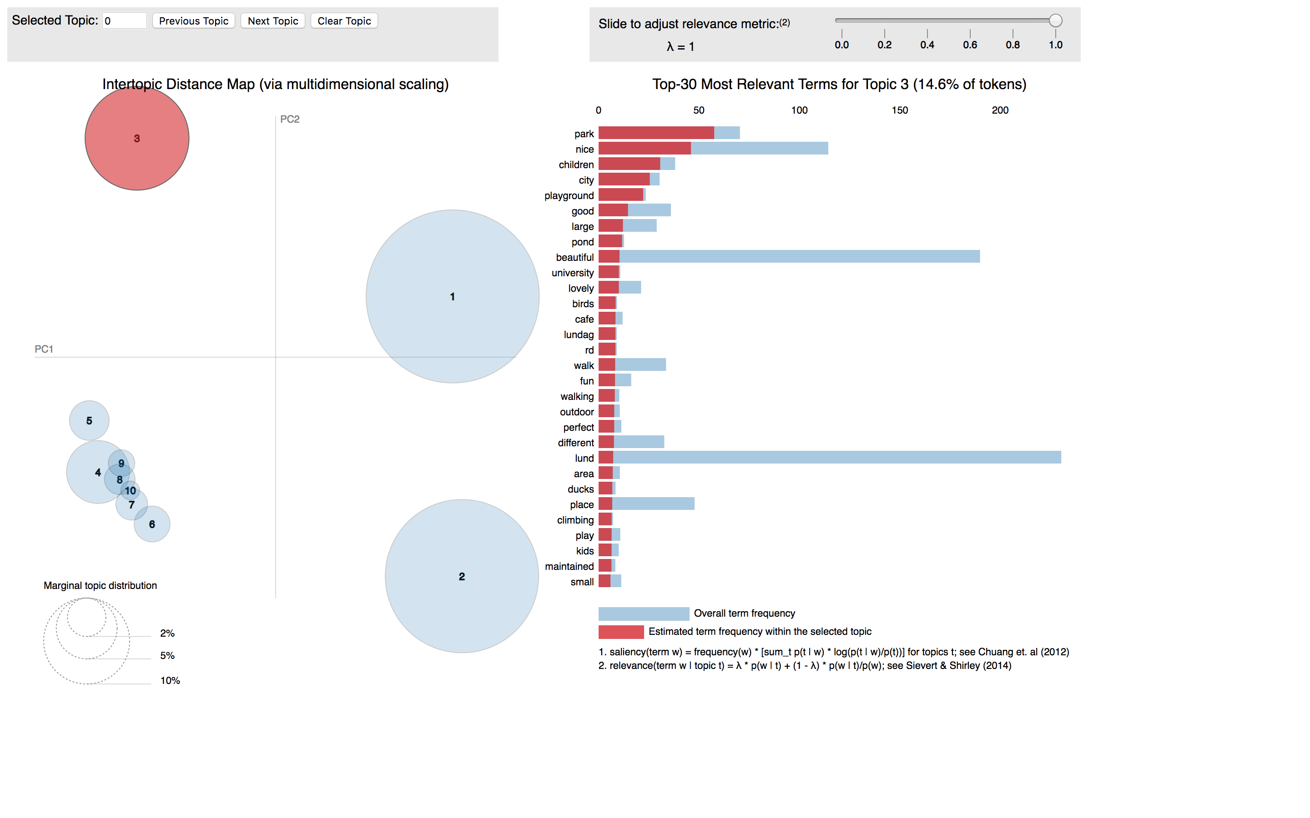

## Danish:

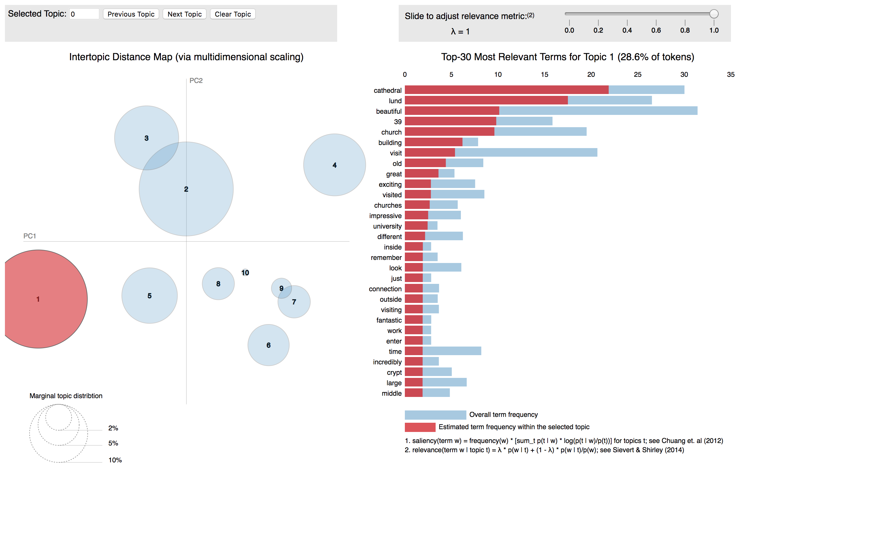

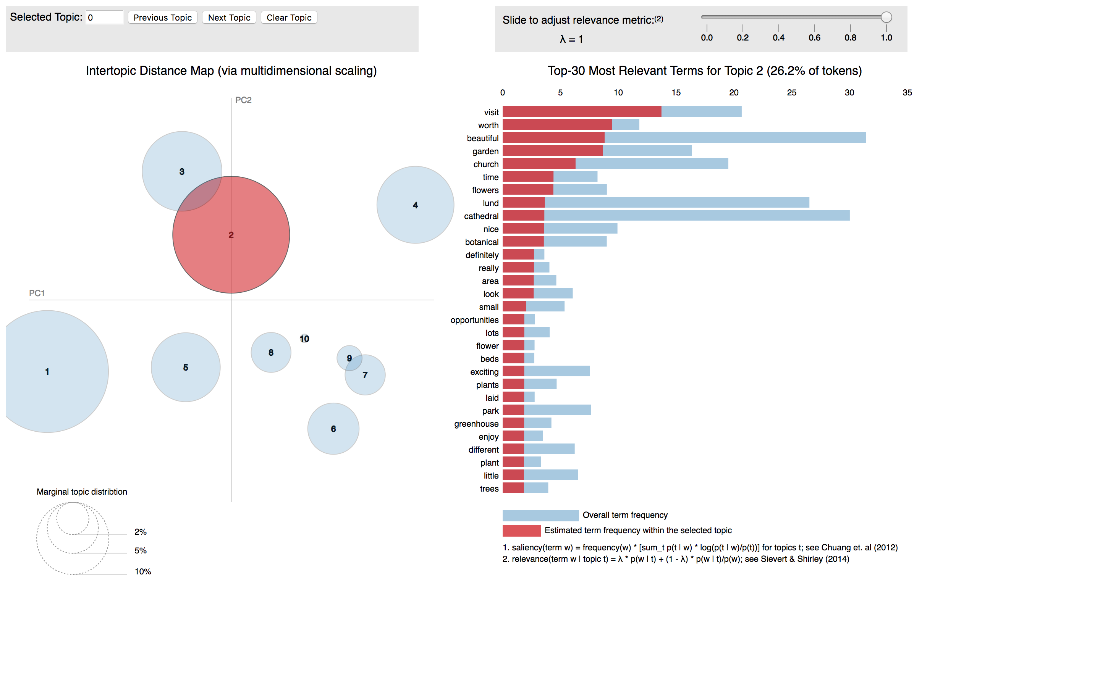

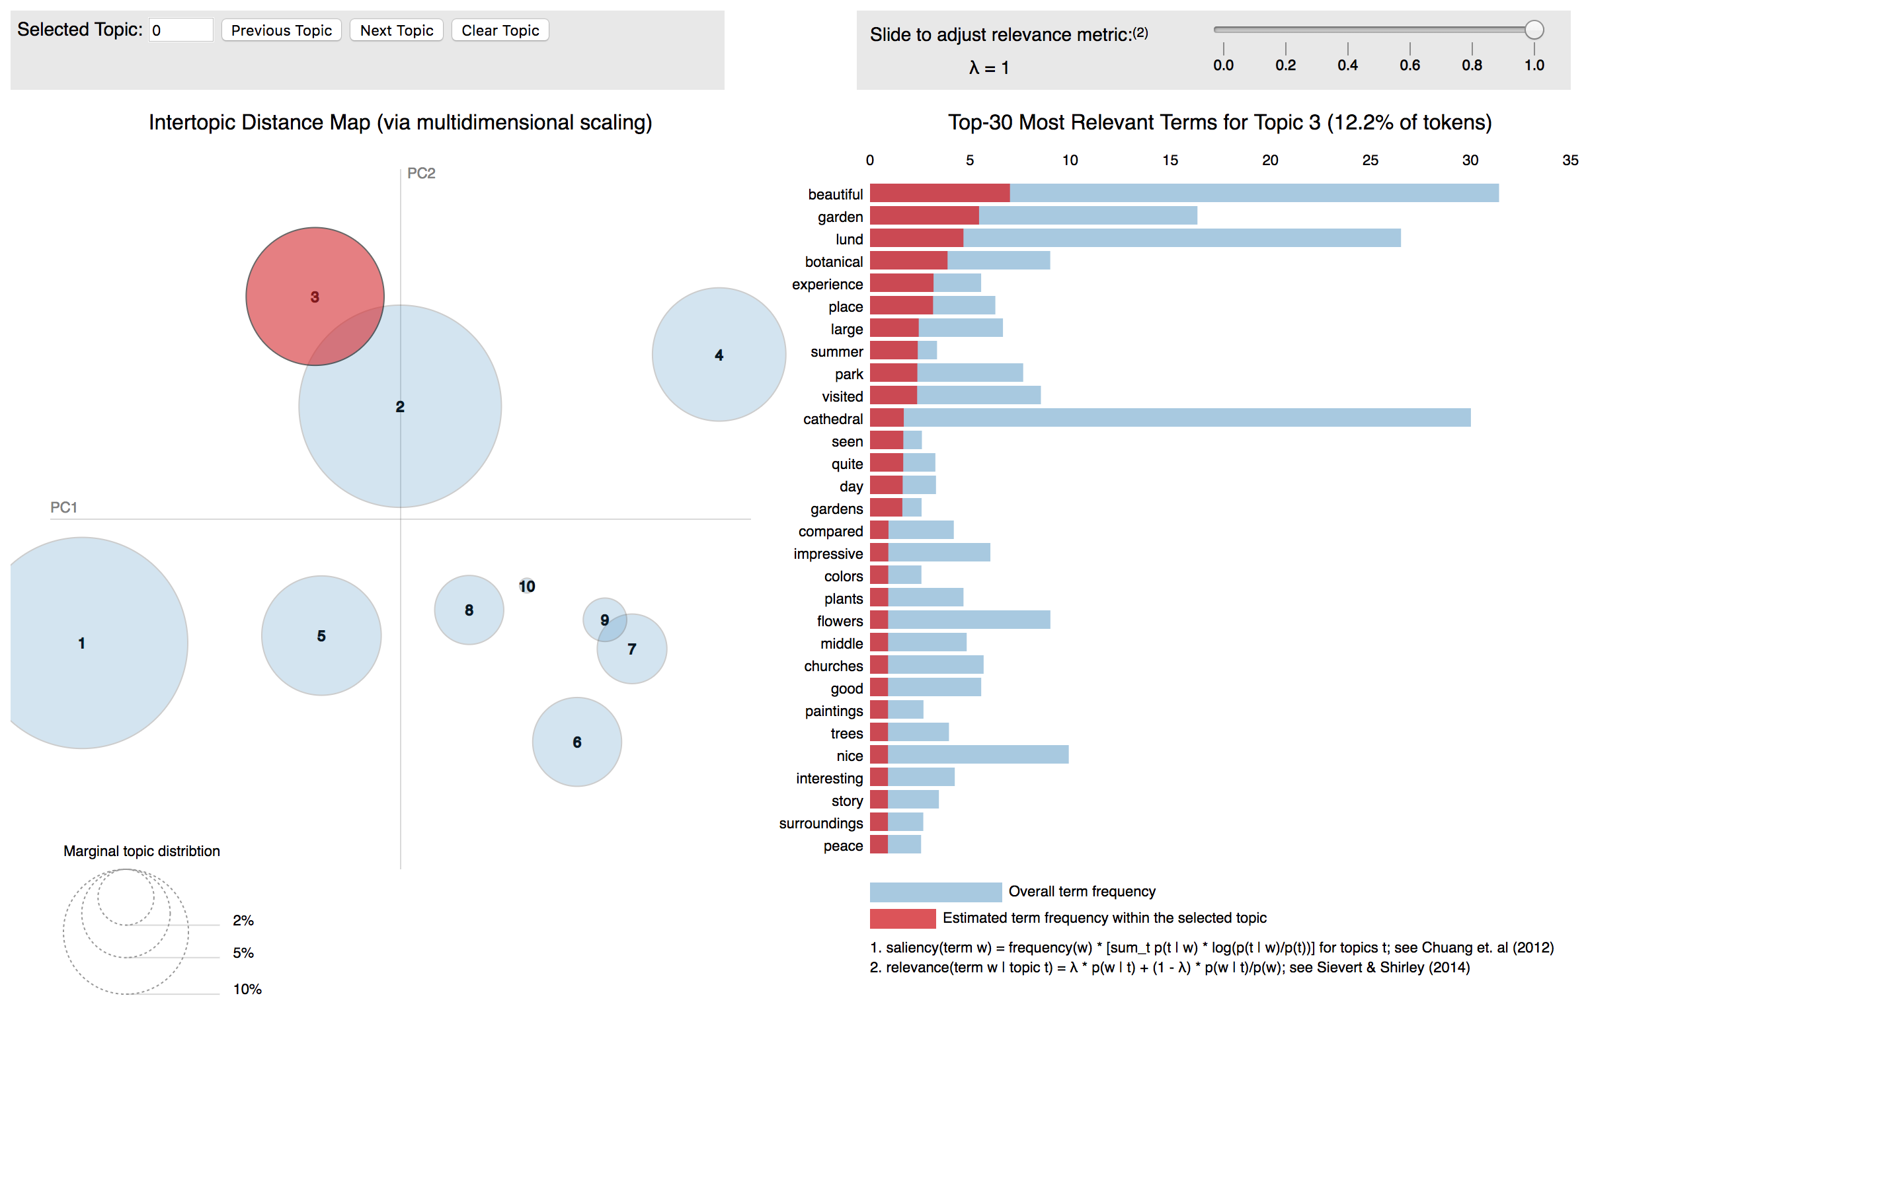

## German:

## Italian:

## French:

## Spanish:

## Japanese:

## Russian:

## Portuguese:

## Chinese Sim:

## Chinese Tra: